Strengthening
Band abduction walk- hinge hips slightly, keep shoulders still and side step, using resistance of band
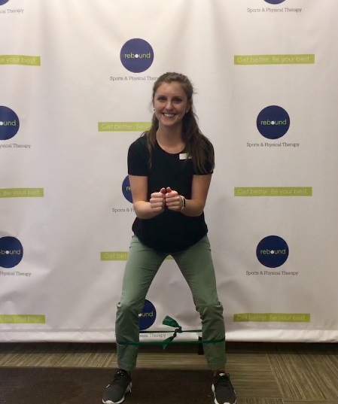
Single Leg Romanian deadlift- holding weight in opposite hand, bend forward trunk/leg together, and squeeze glute upon standing
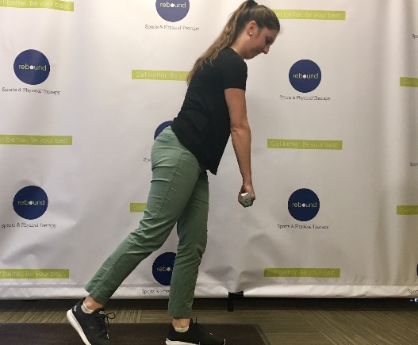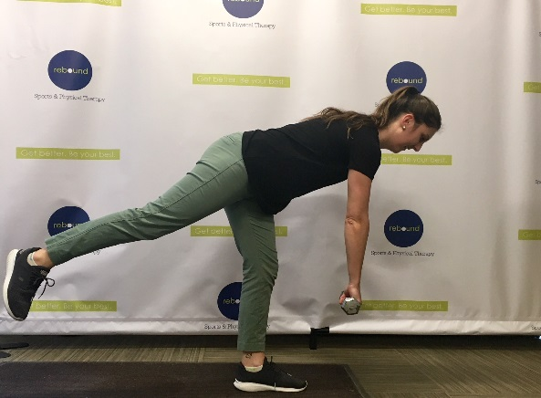
Reverse lunge- step back and lunge back, make sure front knee doesn’t come forward or in, weight through front heel
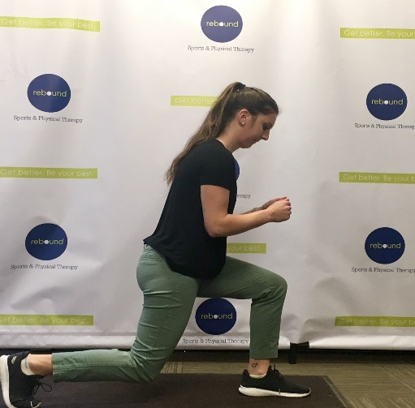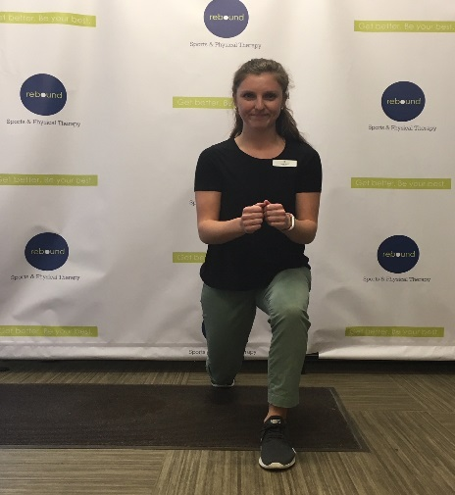
Renegade Row- plank position, alternate rows making sure to stay stable, don’t arch back
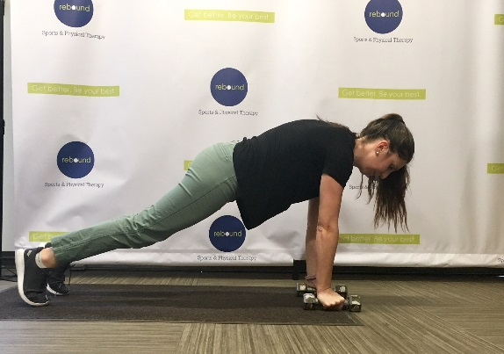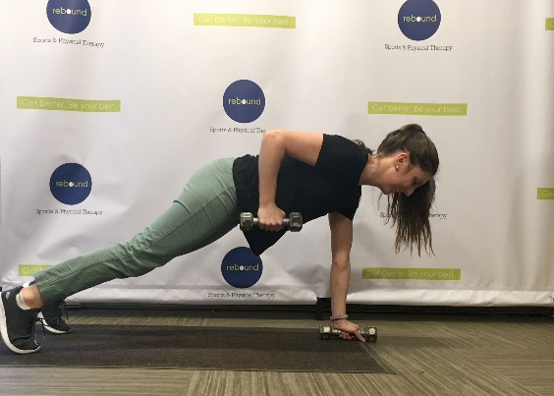
Side planks from elbow- don’t arch back, keep abs engaged
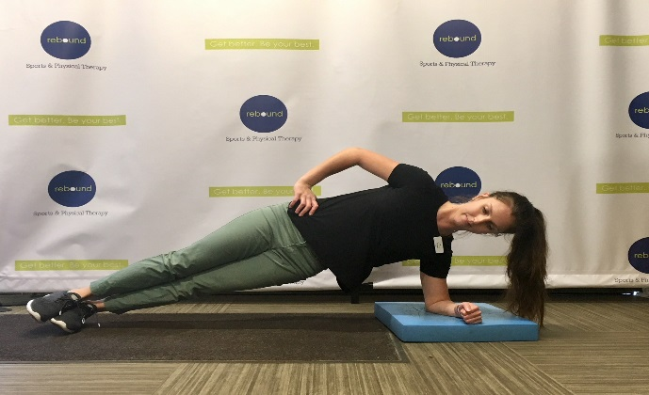

Mobility
Kneeling thoracic hands on ball thoracic extension and lat stretch- roll forward onto ball until arms are straight out, extend through thoracic spine (arrow). Hold position performing slow oscillations of thoracic extension
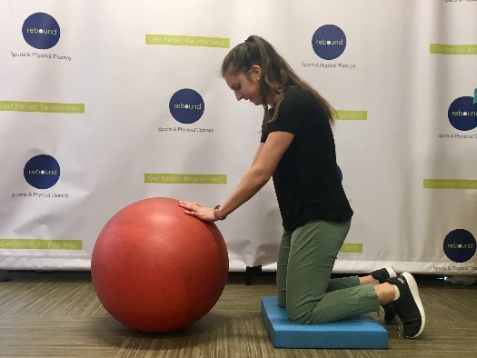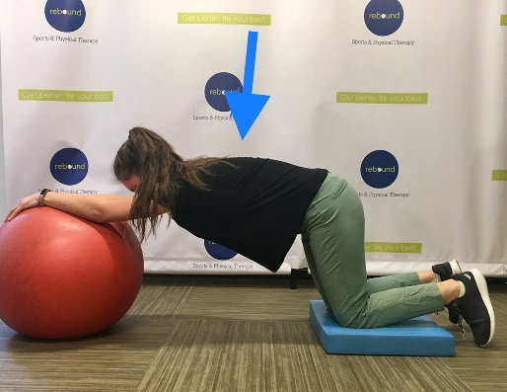

Foam roller pec stretch- keep back flat, palms up
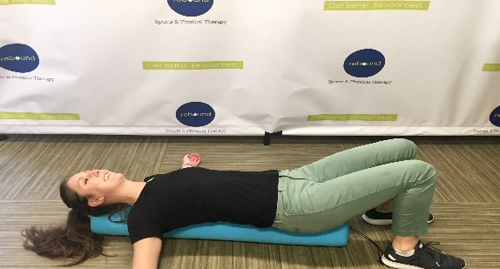
Foam roll quadriceps and calves
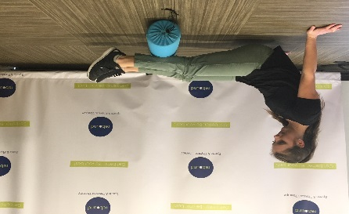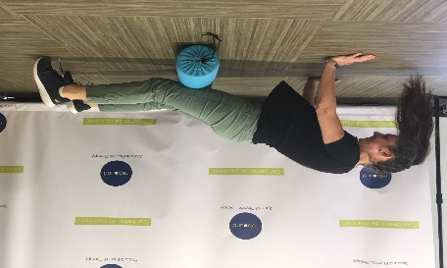
Thoracic rotation- on hands and knees, abs engaged. Hand behind neck, rotate arm/thorax up towards ceiling, and then back down, reaching underneath
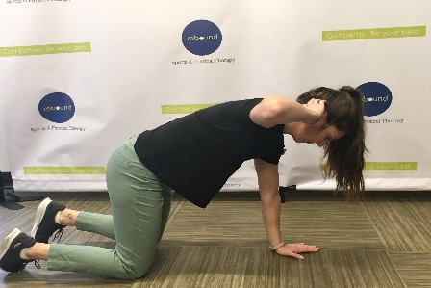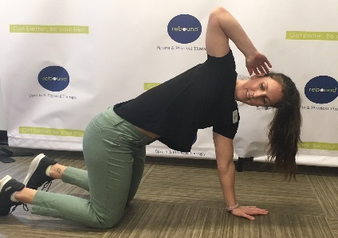
Kneeling hip flexor stretch- lunge position, chest up, squeeze glute. Avoid arching back
